P6.1)

syms A b ;

b=[1;1];

A=[1 1;(1+sqrt(sym(5)))/2 (1-sqrt(sym(5)))/2];

sol=simplify(A\b)

c1= 5^(1/2)/10 + 1/2

c2= 1/2 - 5^(1/2)/10

n=25

fn=c1*((1+sqrt(5))/2)^n+c2*((1-sqrt(5))/2)^n

sol = 5^(1/2)/10 + 1/2

1/2 - 5^(1/2)/10

fn = 121393

P6.3)

syms lh;

sgm=(-2-+sqrt(1+2*lh))/(2*lh-3);

tr=taylor(exp(lh),lh,'Order', 6)

err = taylor(exp(lh),lh,'Order', 6)-taylor(sgm, lh, 'Order', 6)

tr =lh^5/120 + lh^4/24 + lh^3/6 + lh^2/2 + lh + 1

err =- (11*lh^5)/30 - lh^4/12 - lh^3/3

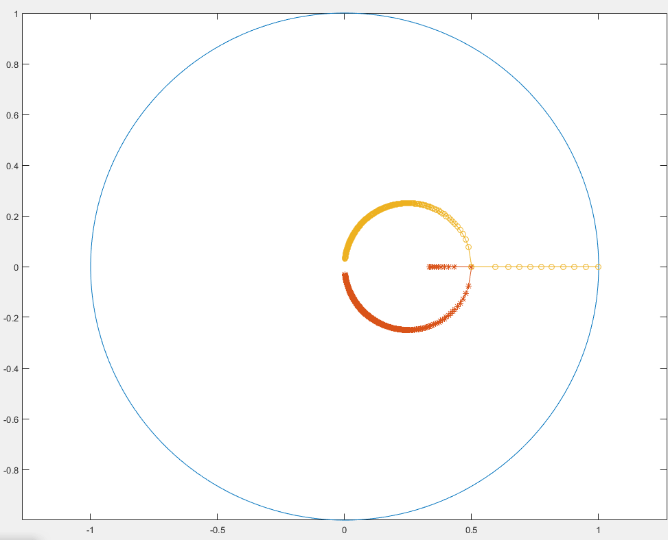(d)

x=linspace(0,8,2000);

plot(sin(x),cos(x)); % Draw the circle

hold on;

lh=0:-0.05:-500; % lamda*h from[0,-500]

s1=(-2+sqrt(2.*lh+1))./(2.*lh-3);

s2=(-2-sqrt(2.*lh+1))./(2.*lh-3);

plot(s1,'-*')

plot(s2,'-o')

axis equal;

hold off;

x=linspace(0,8,2000);

plot(sin(x),cos(x));

hold on;

wh=(0:0.1:10000);

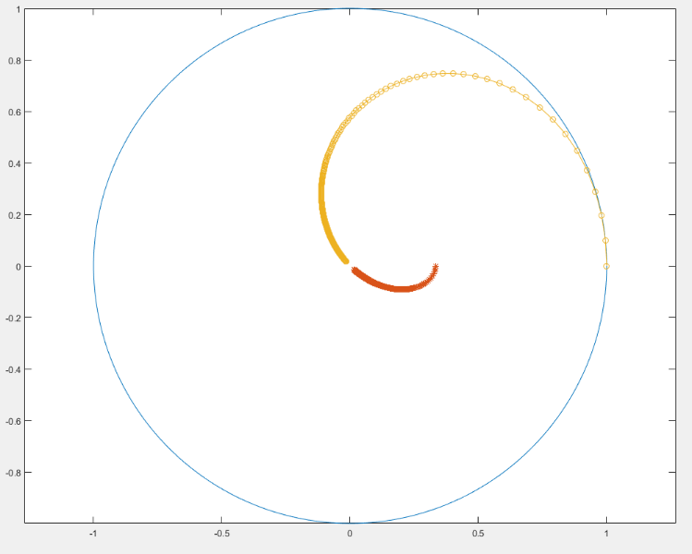lh=wh*i;

s1=(-2+sqrt(2.*lh+1))./(2.*lh-3);

s2=(-2-sqrt(2.*lh+1))./(2.*lh-3);

plot(s1,'-*')

plot(s2,'-o')

axis equal;

hold off;

P6.6)

syms E l h l ;

P=[E^(1/3) 0 -(1+h*l/3) ;-h*l/2*E^(1/3)...

E^0.5 -1;0 -h*l*E^0.5 E-1];

B=simplify(det(P));

Q=P;

Q(:,3)=[h/3;h/2*exp(muh)^(1/3);h*exp(muh)^(1/2)];

eqn=B==0;

sol=solve(eqn,E)

Q=P;

Q(:,3)=[h/3;h/2*E^(1/3);h*E^(1/2)];

ratio=simplify(det(Q)/det(P))

sol = 0

(h^3*l^3)/6 + (h^2*l^2)/2 + h*l + 1

ratio =-(h*(6*E^(1/2) + h^2*l^2 + 3*E^(1/3)*h*l))/(h^3*l^3 + 3*h^2*l^2 + 6*h*l - 6*E + 6)

syms lh;

expression=exp(lh)-1-lh-lh^2/2-1/6*lh^3;

taylor(expression,lh, 'Order', 8)

ans =lh^7/5040 + lh^6/720 + lh^5/120 + lh^4/24

syms E l h l mu ;

P=[(exp(mu*h))^(1/3) 0 -(1+h*l/3) ;-h*l/2*(exp(mu*h))^(1/3)...

(exp(mu*h))^0.5 -1; 0 -h*l*(exp(mu*h))^0.5 exp(mu*h)-1];

B=simplify(det(P));

Q=P;

Q(:,3)=[h/3;h/2*(exp(mu*h))^(1/3); h*(exp(mu*h))^(1/2)];

eru=det(Q)-det(P)/(mu-l)

taylor(eru,h)

eru =h*exp(h*mu)^(4/3) - (exp(h*mu)^(5/6) - exp(h*mu)^(11/6) + h*l*exp(h*mu)^(5/6) + (h^2*l^2*exp(h*mu)^(5/6))/2 + (h^3*l^3*exp(h*mu)^(5/6))/6)/(l - mu) + (h^2*l*exp(h*mu)^(7/6))/2 + (h^3*l^2*exp(h*mu)^(5/6))/6

ans=((343*l*mu^3)/2592 - ((25*l^3*mu^2)/432 + (125*l^2*mu^3)/2592 + (625*l*mu^4)/31104 - (26321*mu^5)/155520)/(l - mu) + (32*mu^4)/243 + (25*l^2*mu^2)/432)*h^5 + ((49*l*mu^2)/144 - ((5*l^3*mu)/36 + (25*l^2*mu^2)/144 + (125*l*mu^3)/1296 - (73*mu^4)/162)/(l - mu) + (5*l^2*mu)/36 + (32*mu^3)/81)*h^4 + ((7*l*mu)/12 - (l^3/6 + (5*l^2*mu)/12 + (25*l*mu^2)/72 - (67*mu^3)/72)/(l - mu) + l^2/6 + (8*mu^2)/9)*h^3

P(7.4)

A=[-1 -1 -1 -1;0 1 2 3;0 -0.5 -2 -4.5;0 1/6 4/3 27/6];

b=[-1;-0.5;-1/6;-1/24];

ss= A\b;

ss =

2.291666666666667

-2.458333333333333

1.541666666666667

-0.375000000000000

%% AB1

step_size=0.1;

syms lh;

p=[];

for Re=-1:step_size:1;

Re

im=sqrt(1-Re^2);

sgm=Re+im*i;

lh=sgm-1;

p=[p;real(lh), imag(lh)];

hold on;

im=-sqrt(1-Re^2);

sgm=Re+im*i;

lh=sgm-1;

p=[p;real(lh), imag(lh)];

end

plot(p(:,1),p(:,2), '*');

axis equal;

%% AB2

syms lh;

p=[];

for Re=-1:step_size:1;

Re

im=sqrt(1-Re^2);

sgm=Re+im*i;

eqn=sgm^2-(1+1.5*lh)*sgm+0.5*lh==0;

solx = double(solve(eqn,lh));

p=[p;real(solx), imag(solx)];

hold on;

im=-sqrt(1-Re^2);

sgm=Re+im*i;

eqn=sgm^2-(1+1.5*lh)*sgm+0.5*lh==0;

solx = double(solve(eqn,lh));

p=[p;real(solx), imag(solx)];

end

plot(p(:,1),p(:,2), 'x');

axis equal;

%% AB3

syms lh;

p=[];

for Re=-1:step_size:1;

Re

im=sqrt(1-Re^2);

sgm=Re+im*i;

eqn=sgm^3-(1+23/12*lh)*sgm^2+16/12*lh*sgm-5/12*lh==0;

solx = double(solve(eqn,lh));

p=[p;real(solx), imag(solx)];

hold on;

im=-sqrt(1-Re^2);

sgm=Re+im*i;

eqn=sgm^3-(1+23/12*lh)*sgm^2+16/12*lh*sgm-5/12*lh==0;

solx = double(solve(eqn,lh));

p=[p;real(solx), imag(solx)];

end

plot(p(:,1),p(:,2), 'o');

axis equal;

%% AB4

syms lh;

p=[];

for Re=-1:0.02:1;

Re

im=sqrt(1-Re^2);

sgm=Re+im*i;

eqn=24*sgm^4-(24+55*lh)*sgm^3+59*lh*sgm^2-37*lh*sgm+9*lh==0;

solx = double(solve(eqn,lh));

p=[p;real(solx), imag(solx)];

hold on;

im=-sqrt(1-Re^2);

sgm=Re+im*i;

eqn=24*sgm^4-(24+55*lh)*sgm^3+59*lh*sgm^2-37*lh*sgm+9*lh==0;

solx = double(solve(eqn,lh));

p=[p;real(solx), imag(solx)];

end

plot(p(:,1),p(:,2), '.');

axis equal;

legend('AB1','AB2','AB3','AB4')

hold off;

figure;

%% RK1

step_size=0.1;

syms lh;

p=[];

for Re=-1:step_size:1;

Re

im=sqrt(1-Re^2);

sgm=Re+im*i;

lh=sgm-1;

p=[p;real(lh), imag(lh)];

hold on;

im=-sqrt(1-Re^2);

sgm=Re+im*i;

lh=sgm-1;

p=[p;real(lh), imag(lh)];

end

plot(p(:,1),p(:,2), '*');

axis equal;

%% RK2

syms lh;

p=[];

for Re=-1:step_size:1;

Re

im=sqrt(1-Re^2);

sgm=Re+im*i;

eqn=sgm-1-lh-0.5*lh^2==0;

solx = double(solve(eqn,lh));

p=[p;real(solx), imag(solx)];

hold on;

im=-sqrt(1-Re^2);

sgm=Re+im*i;

eqn=sgm-1-lh-0.5*lh^2==0;

solx = double(solve(eqn,lh));

p=[p;real(solx), imag(solx)];

end

plot(p(:,1),p(:,2), 'x');

axis equal;

%% RK3

syms lh;

p=[];

for Re=-1:step_size:1;

Re

im=sqrt(1-Re^2);

sgm=Re+im*i;

eqn= lh^3/6 + lh^2/2 + lh + 1-sgm==0;

solx = double(solve(eqn,lh));

p=[p;real(solx), imag(solx)];

hold on;

im=-sqrt(1-Re^2);

sgm=Re+im*i;

eqn= lh^3/6 + lh^2/2 + lh + 1-sgm==0;

solx = double(solve(eqn,lh));

p=[p;real(solx), imag(solx)];

end

plot(p(:,1),p(:,2), 'x');

axis equal;

%% RK4

syms lh;

p=[];

for Re=-1:step_size:1;

Re

im=sqrt(1-Re^2);

sgm=Re+im*i;

eqn=sgm-1-lh-0.5*lh^2-1/6*lh^3-1/24*lh^4==0;

solx = double(solve(eqn,lh));

p=[p;real(solx), imag(solx)];

hold on;

im=-sqrt(1-Re^2);

sgm=Re+im*i;

eqn=sgm-1-lh-0.5*lh^2-1/6*lh^3-1/24*lh^4==0;

solx = double(solve(eqn,lh));

p=[p;real(solx), imag(solx)];

end

plot(p(:,1),p(:,2), 'x');

axis equal;

legend('RK1','RK2','RK3','RK4')

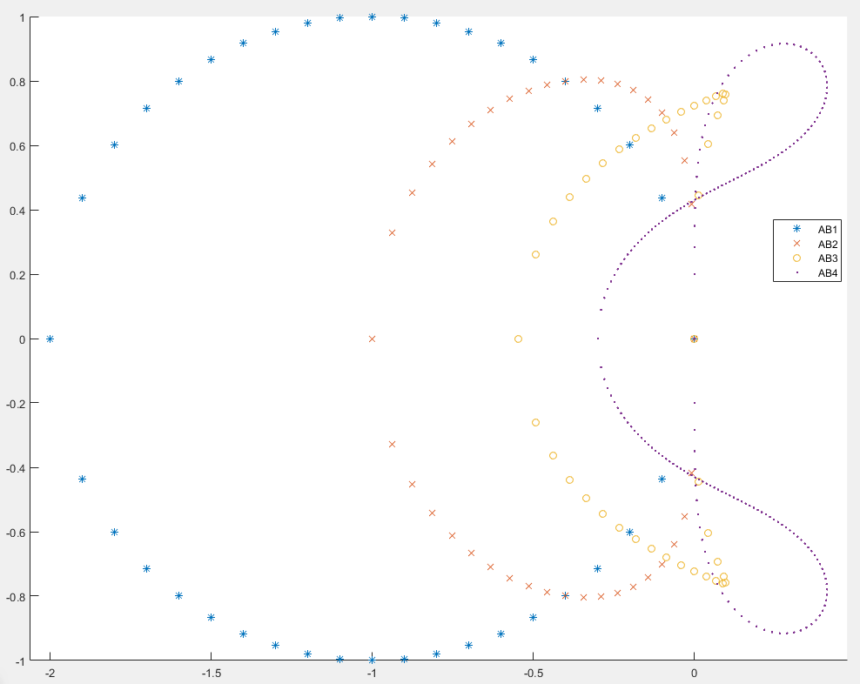

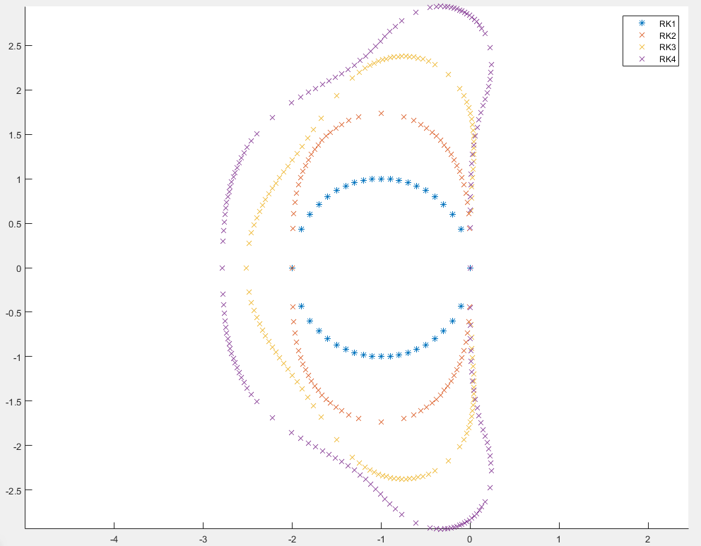

P7.5)

syms sgm lh;

expr=(lh/3-1)*sgm^2+4/3*lh*sgm+lh/3+1==0;

soln=solve(expr,sgm)

simplify(soln)

taylor(exp(lh)- -(2*lh + 3^(1/2)*(lh^2 + 3)^(1/2))/(lh - 3),lh,'Order',7)

ans = ans =

- lh^6/180 - lh^5/180- lh^6/180 - lh^5/180

P 8.1)

%% RK2

for N=1:1000

T=-log(0.25);

h=T/N;

l=-1;

sgm=1+l*h+(l*h)^2/2;

err_l=exp(l*T)-sgm^N;

if abs(err_l/exp(l*T))<=0.005

break;

end

end

fprintf('N=%d h=%0.5f sgm1=%0.7f Fev=%d err=%0.7f \n ',N,h,sgm,N*2,err_l)

%% RK3

for N=1:1000

T=-log(0.25);

h=T/N;

l=-1;

sgm=1+l*h+(l*h)^2/2+1/6*(l*h)^3;

err_l=exp(l*T)-sgm^N;

if abs(err_l/exp(l*T))<=0.005

break;

end

end

fprintf('N=%d h=%0.5f sgm1=%0.7f Fev=%d err=%0.7f \n ',N,h,sgm,N*3,err_l)

%% Convection

clear i;

%% RK2 K=100

T=10;

h1=0.1;

K=100;

k=2;

N=K/k;

h1=T/N;

lamda=i;

w=1;

l=i;

sgm1=1+l*h1+(l*h1)^2/2;

Amp=(abs(sgm1))^(N);

N*atan(imag(sgm1)/real(sgm1));

Erw=(w*T-N*atan(imag(sgm1)/real(sgm1)))/pi*180;

fprintf('Amp=%0.5f Erw=%0.3f \n ',Amp,Erw);

%% RK2 K=50

T=10;

h1=0.1;

K=50;

k=2;

N=K/k;

h1=T/N;

lamda=i;

w=1;

l=i;

sgm1=1+l*h1+(l*h1)^2/2;

Amp=(abs(sgm1))^(N);

N*atan(imag(sgm1)/real(sgm1));

Erw=(w*T-N*atan(imag(sgm1)/real(sgm1)))/pi*180;

fprintf('Amp=%0.5f Erw=%0.3f \n ',Amp,Erw);

%% RK3 K=100

T=10;

h1=0.1;

K=100;

k=3;

N=K/k;

h1=T/N;

lamda=i;

w=1;

l=i;

sgm1=1+l*h1+(l*h1)^2/2+1/6*(l*h1)^3;

Amp=(abs(sgm1))^(N);

N*atan(imag(sgm1)/real(sgm1));

Erw=(w*T-N*atan(imag(sgm1)/real(sgm1)))/pi*180;

fprintf('Amp=%0.5f Erw=%0.3f \n ',Amp,Erw)

%% RK3 K=50

T=10;

h1=0.1;

K=50;

k=3;

N=K/k;

h1=T/N;

lamda=i;

w=1;

l=i;

sgm1=1+l*h1+(l*h1)^2/2+1/6*(l*h1)^3;

Amp=(abs(sgm1))^(N);

N*atan(imag(sgm1)/real(sgm1));

Erw=(w*T-N*atan(imag(sgm1)/real(sgm1)))/pi*180;

fprintf('Amp=%0.5f Erw=%0.3f \n ',Amp,Erw)

N=10 h=0.13863 sgm1=0.8709796 Fev=20 err=-0.0012349

N=4 h=0.34657 sgm1=0.7065450 Fev=12 err=0.0007935

Amp=1.01005 Erw=-3.773

Amp=1.08301 Erw=-14.506

Amp=0.98914 Erw=-0.153

Amp=0.92351 Erw=-2.382